Steps to setup windows instance in public subnet and amazon linux2 instance in private subnet.

Step 1: Go to EC2 and select Launch Instance

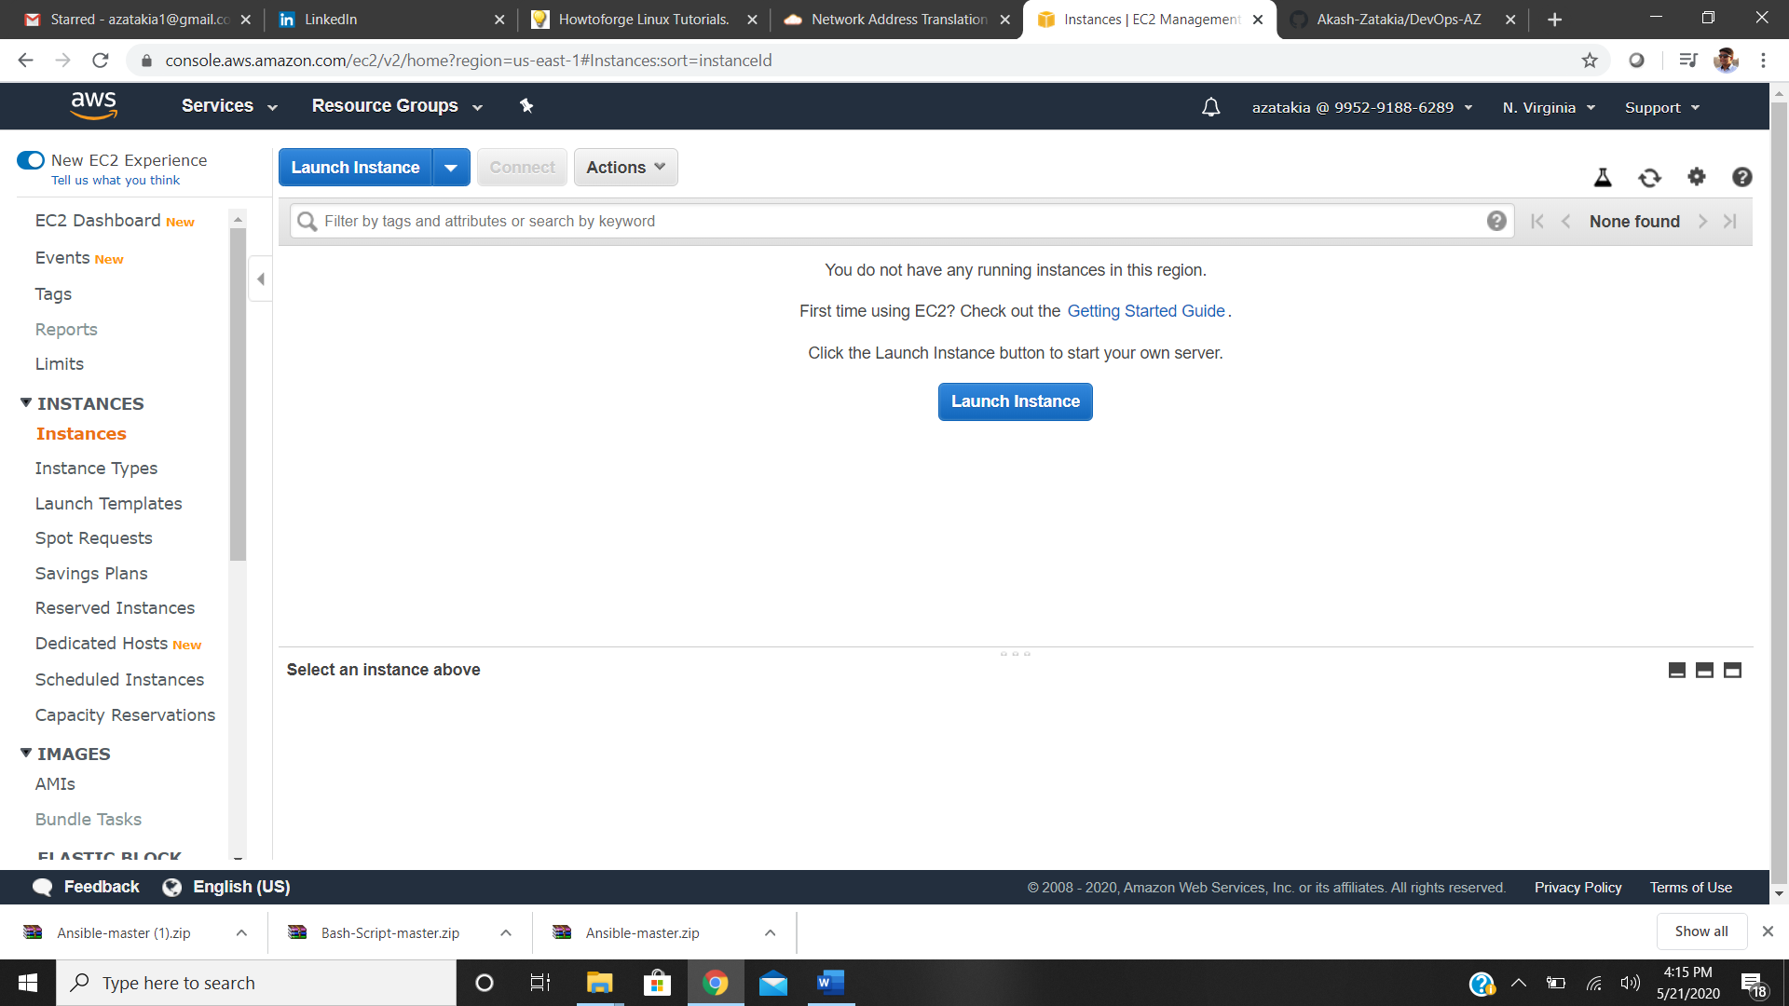

Step 2: Select Microsoft Windows Server 2019 Base (Free Tier)

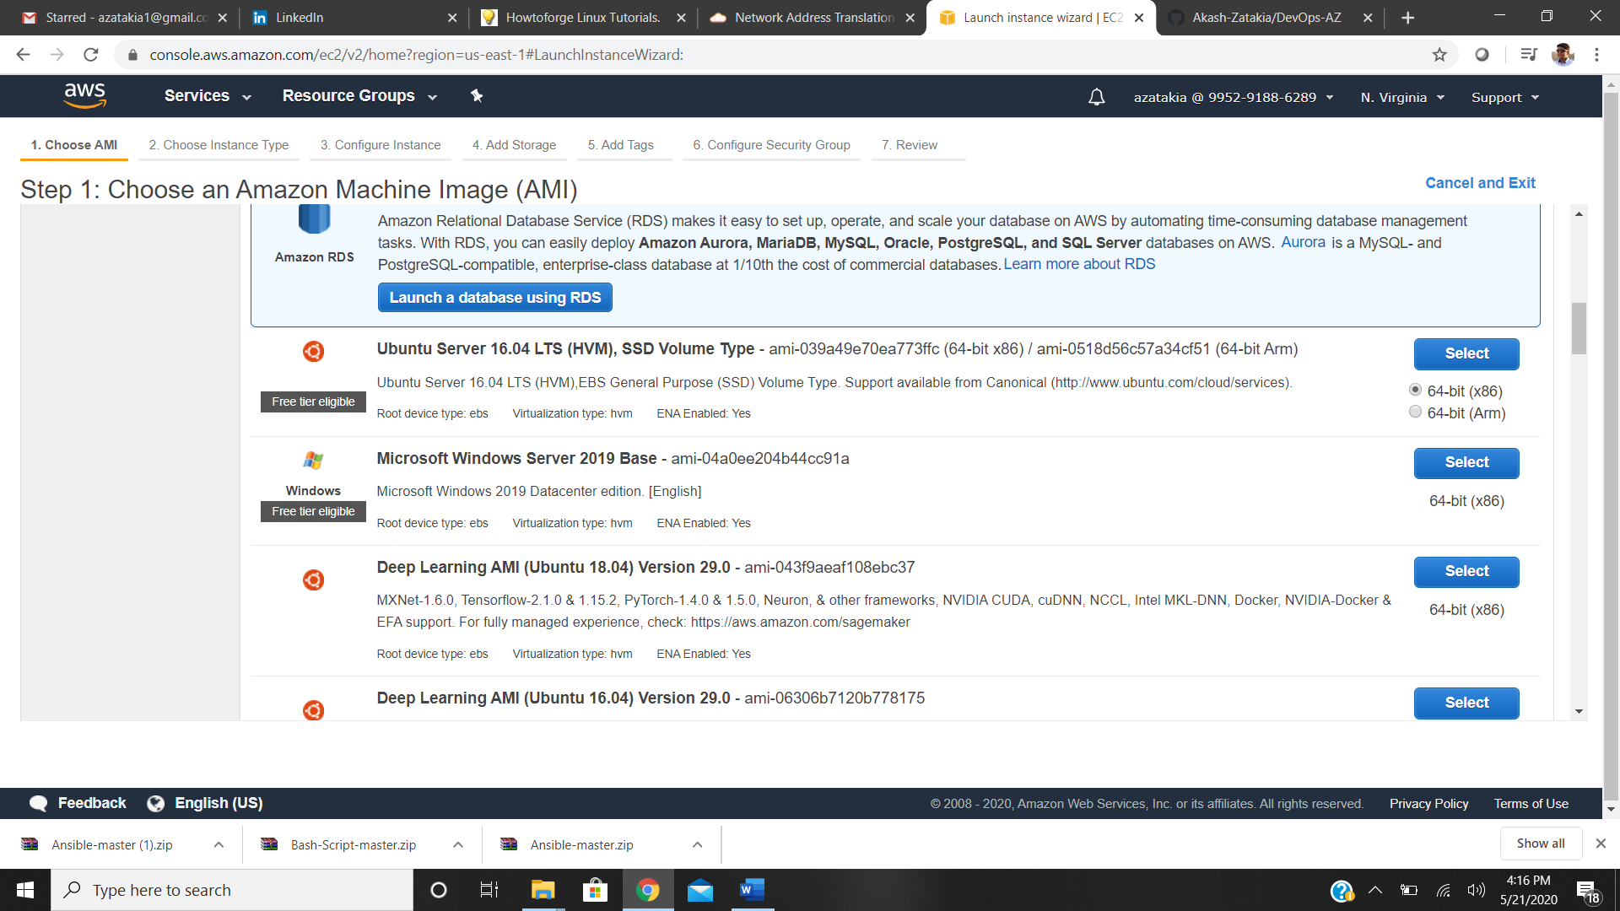

Step 3: Choose the Instance type-t2.micro

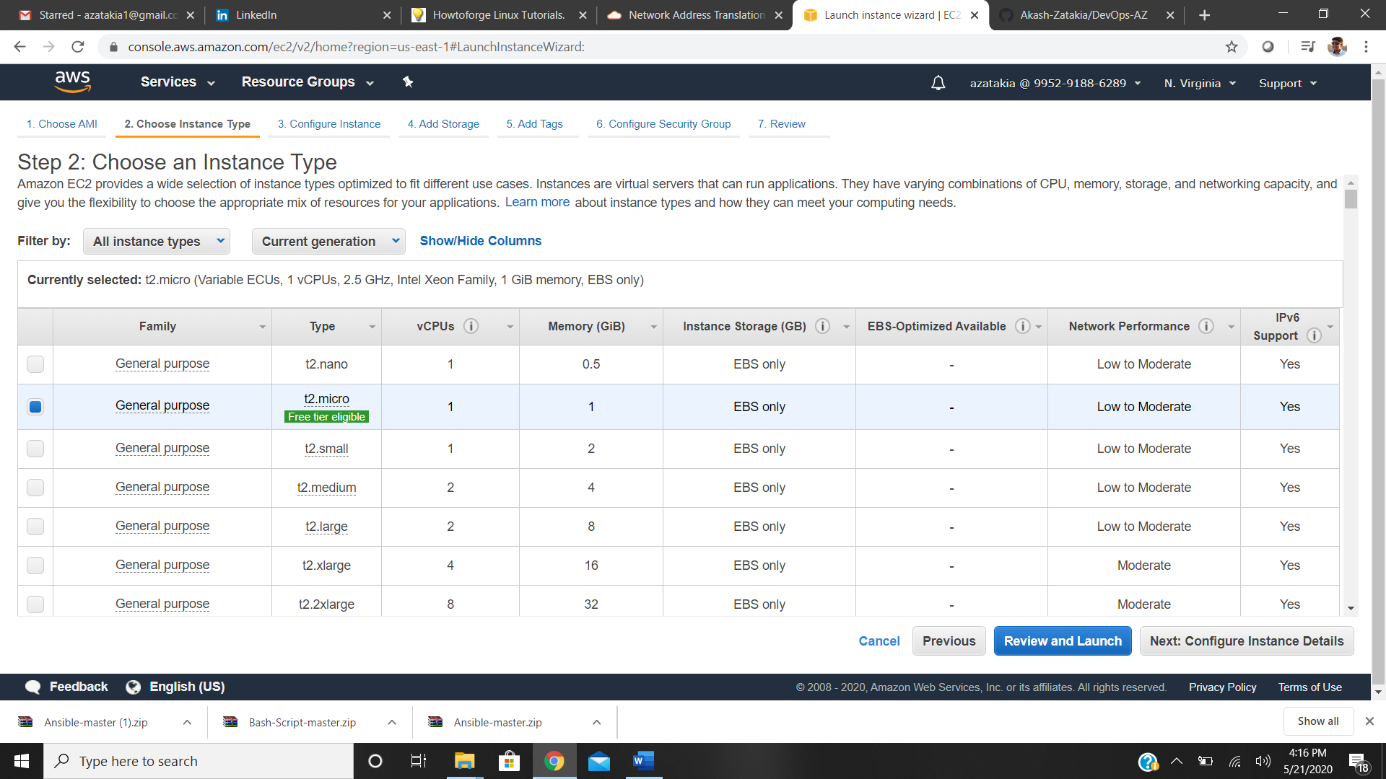

Step 4: Configuring instance details

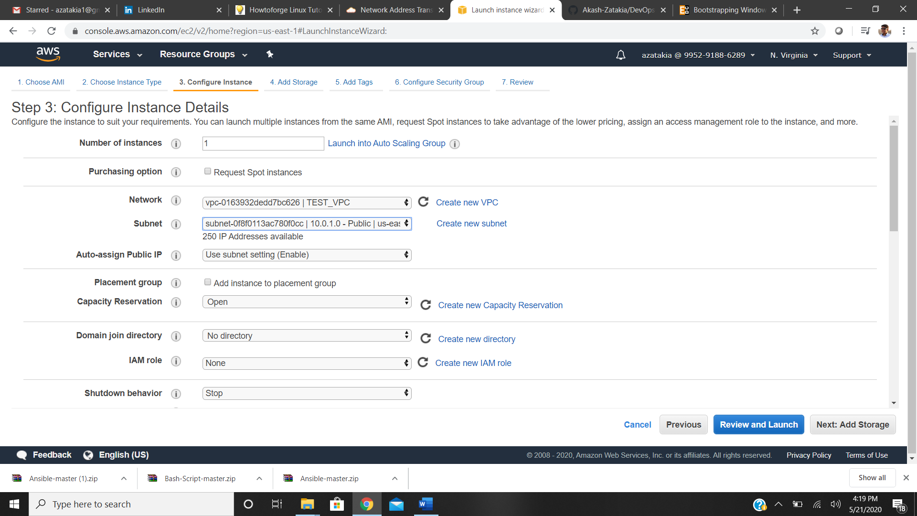

Step 5: Adding Storage

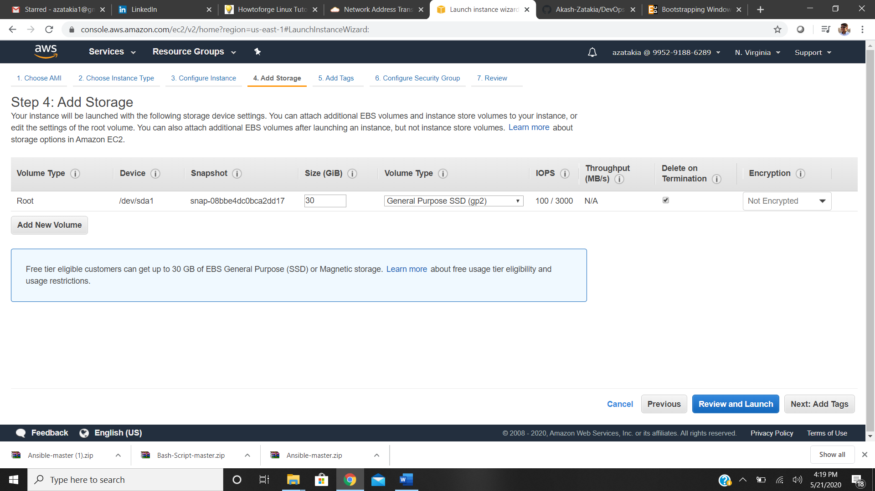

Step 6: Adding Tags

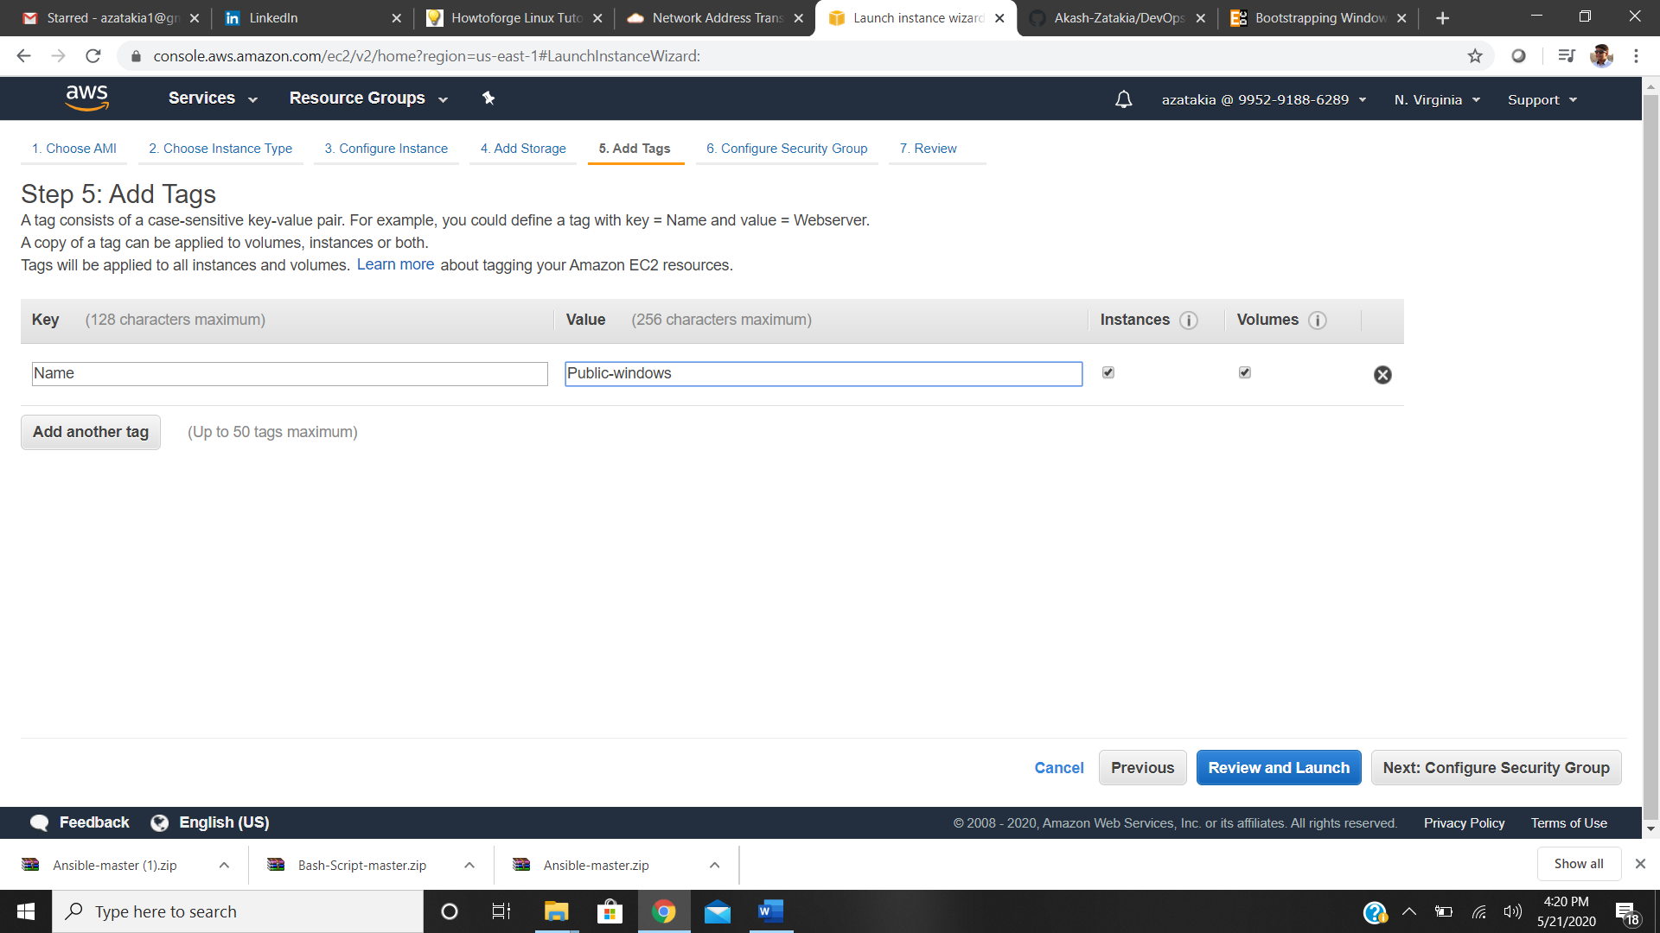

Step 7: Adding Security Group

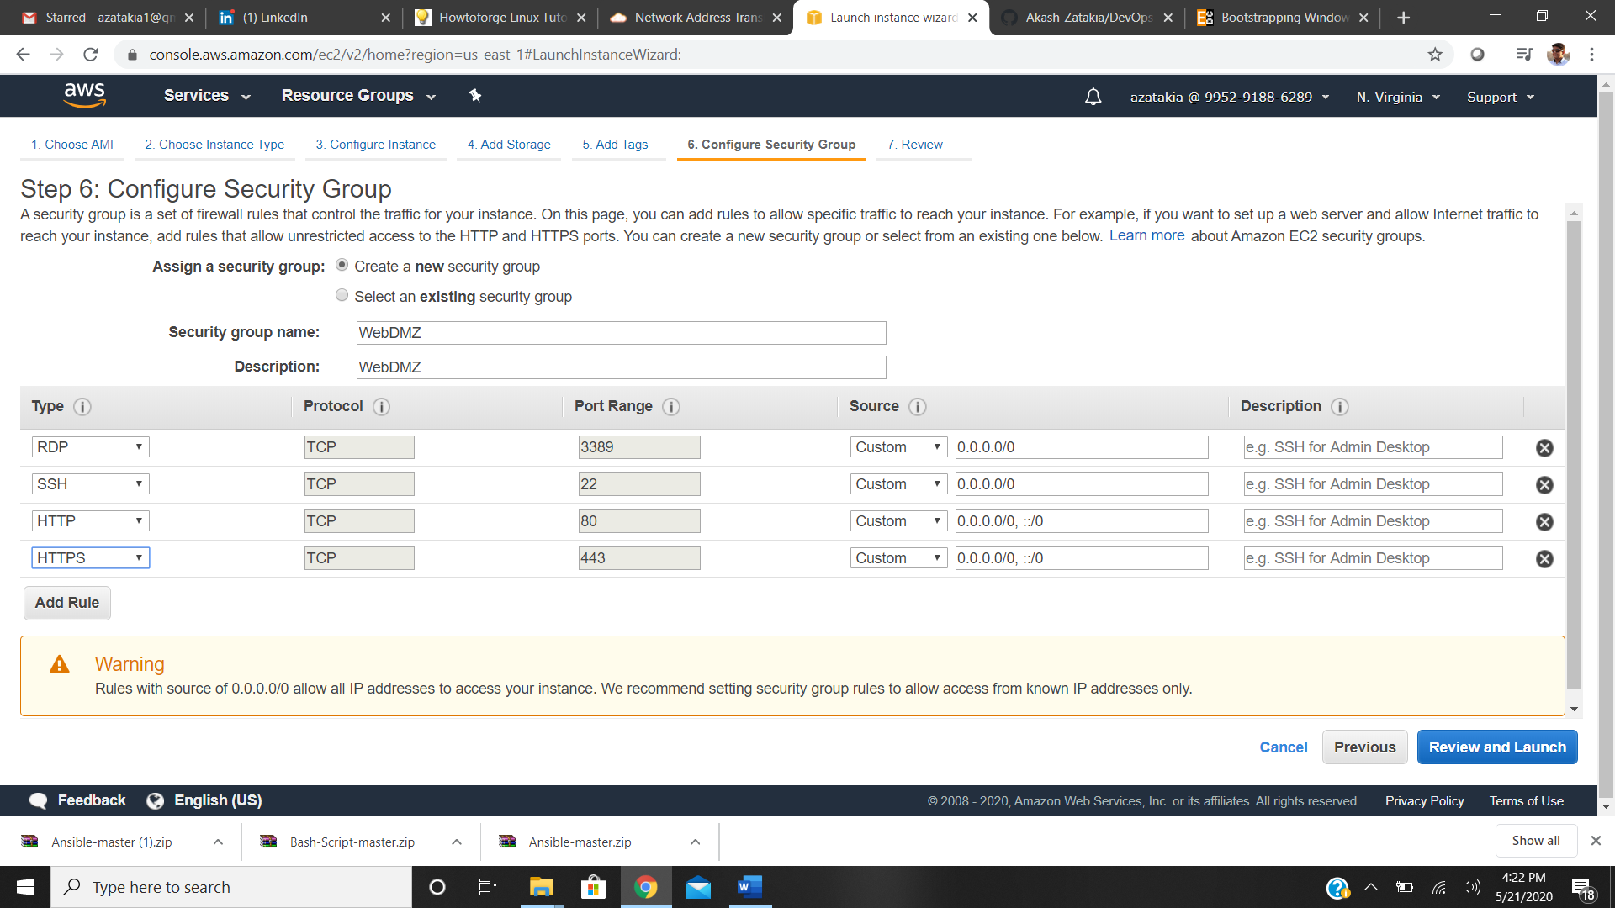

Step 8: Adding Instance in Private Subnet (amazon linux 2)

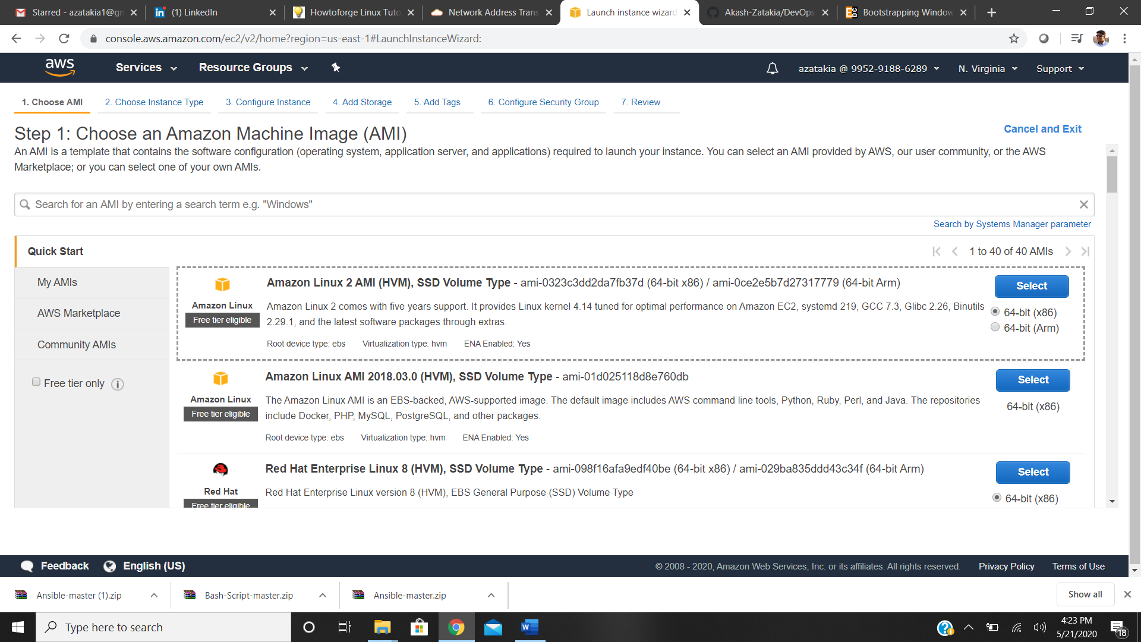

Step 9: Selecting instance type

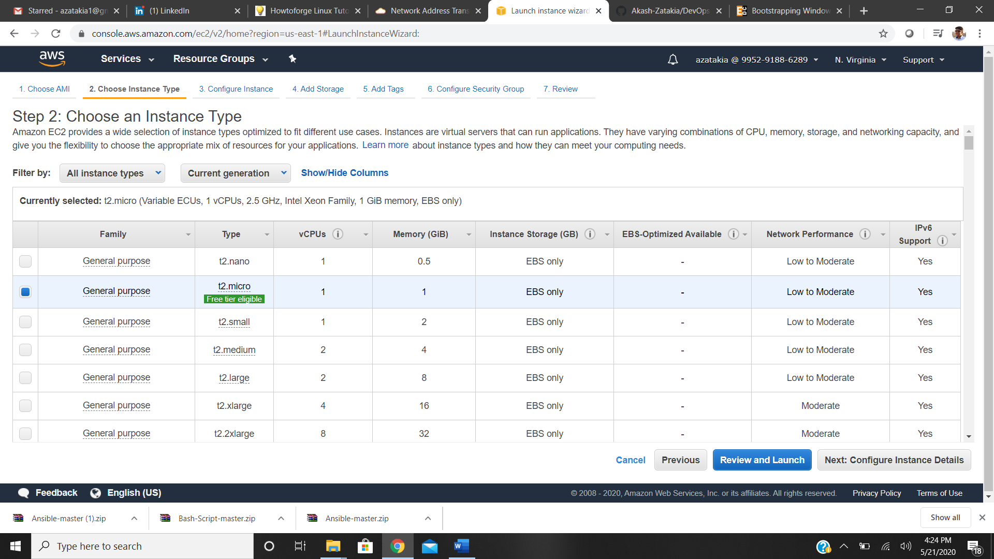

Step 10: Configuring instance details

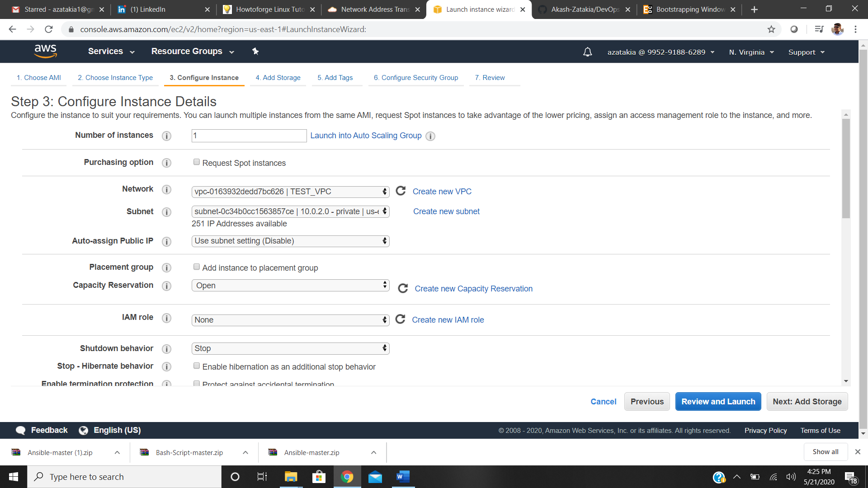

Step 11: Adding Storage

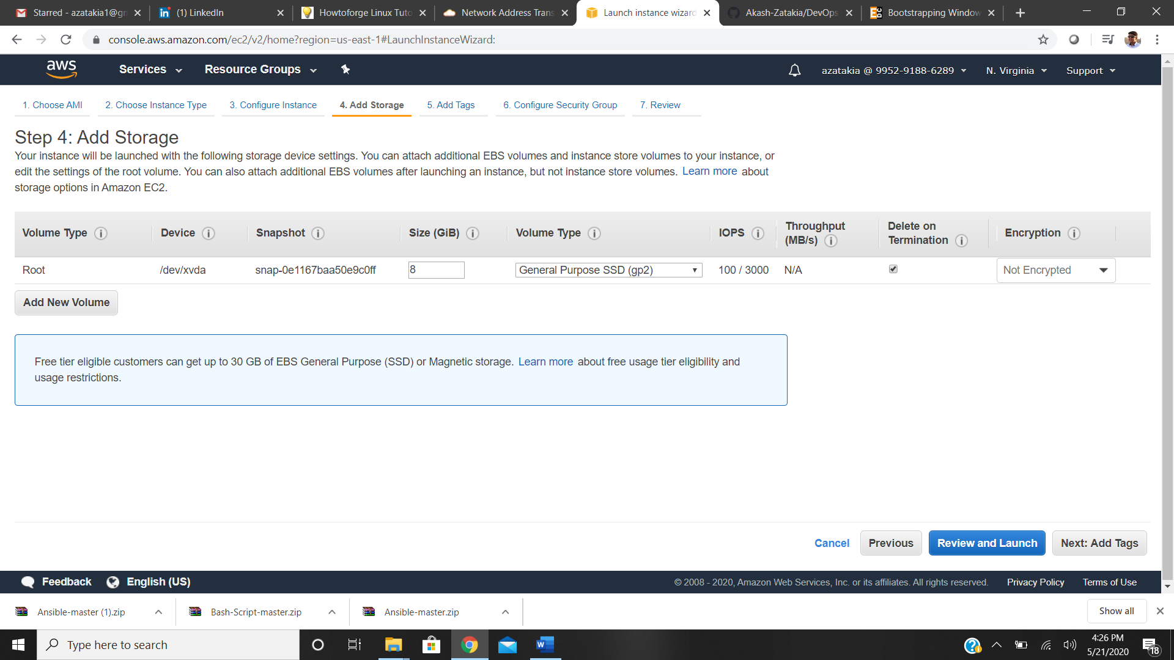

Step 12: Adding Tags

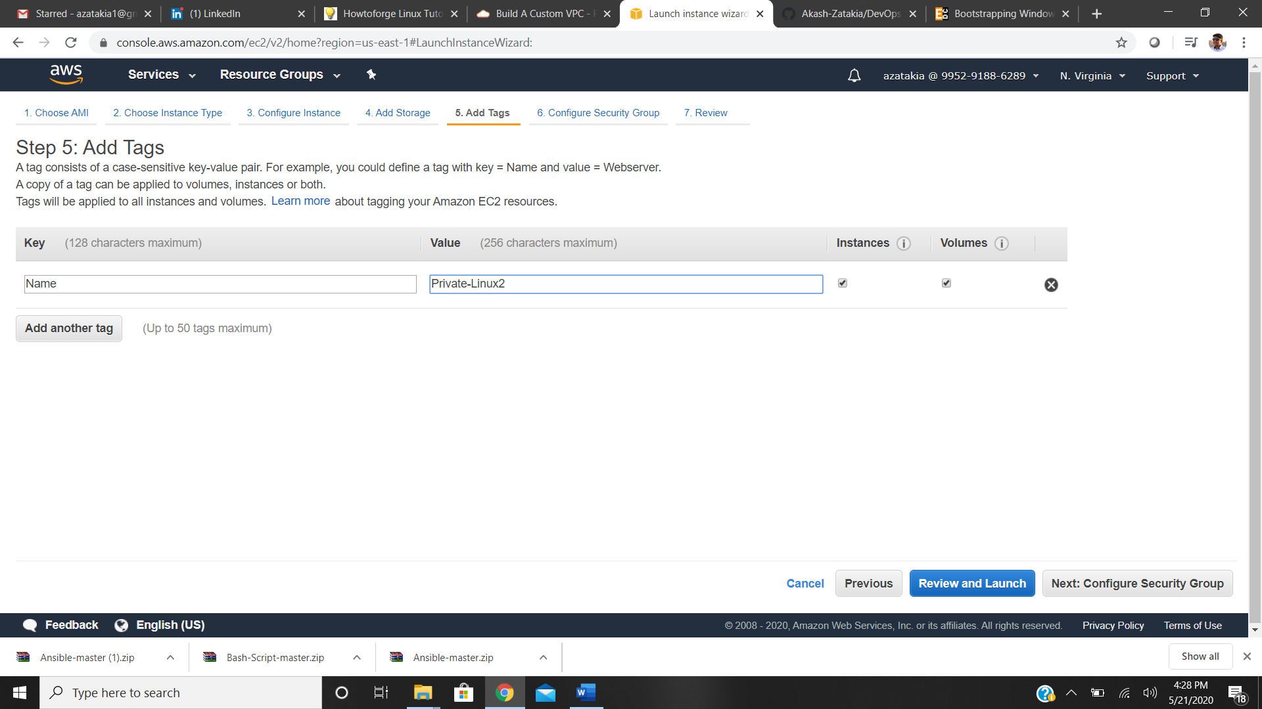

Step 13: Setting up security group

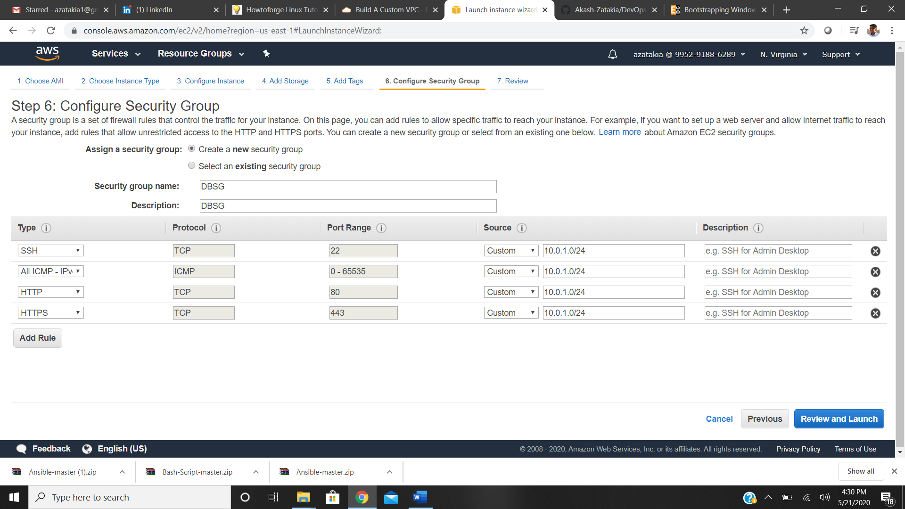

Step 14: launch it

